**Objective**: Create a Tableau dashboard using the provided dataset, incorporating at least 4 different types of visualizations.

Instructions

**Import the Data:**

* Download Global Superstore 2016 file from this page.
* Import the dataset into Tableau.
* Check and correct data types if necessary.

Changed Market and region as Geographic type

**Visual 1:** Sales by Region

* Create a bar chart showing total sales for each region.
* Sort the regions by total sales in descending order.
* Apply a filter to allow users to select specific years. (Use order date)

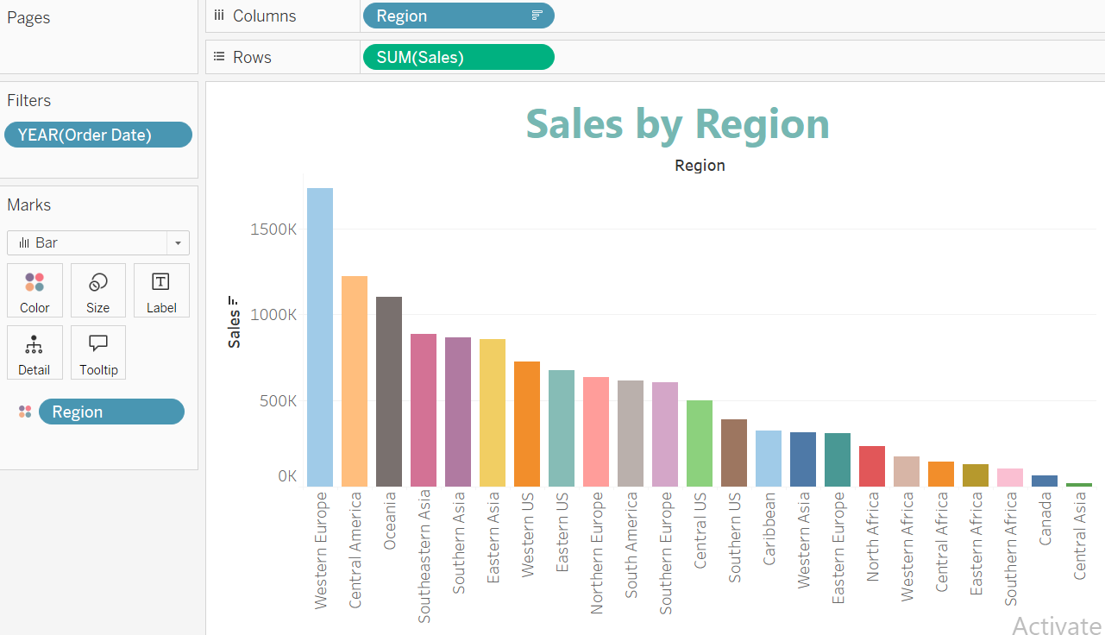

**Visual 2:** Profit Margin by Category

* Create a scatter plot showing profit versus sales for each product category.
* Use colour to distinguish between different categories.

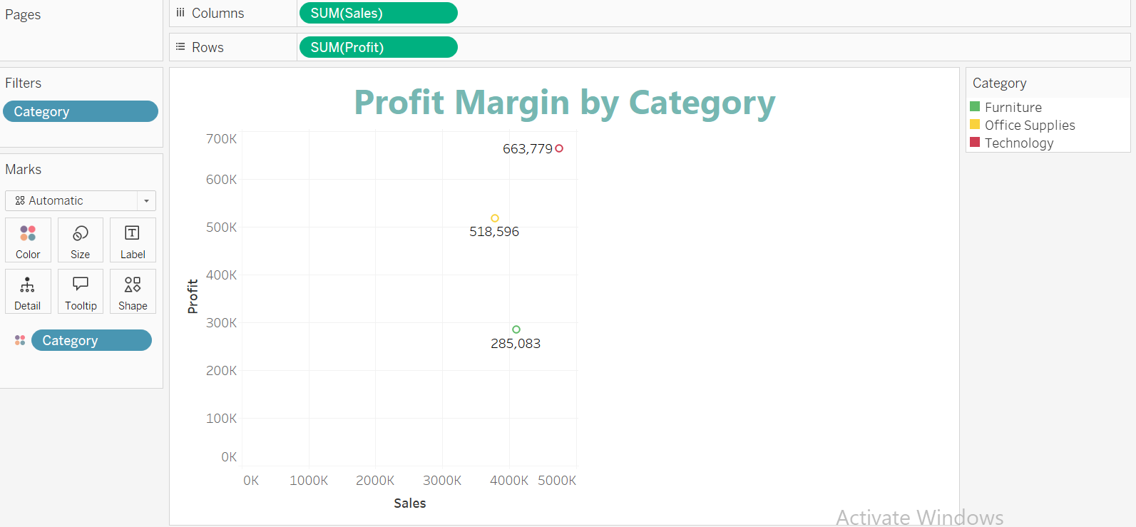

**Visual 3:** Shipping Cost Analysis

* Create a line chart showing average shipping cost over time.
* Use filters to allow users to select different ship modes.

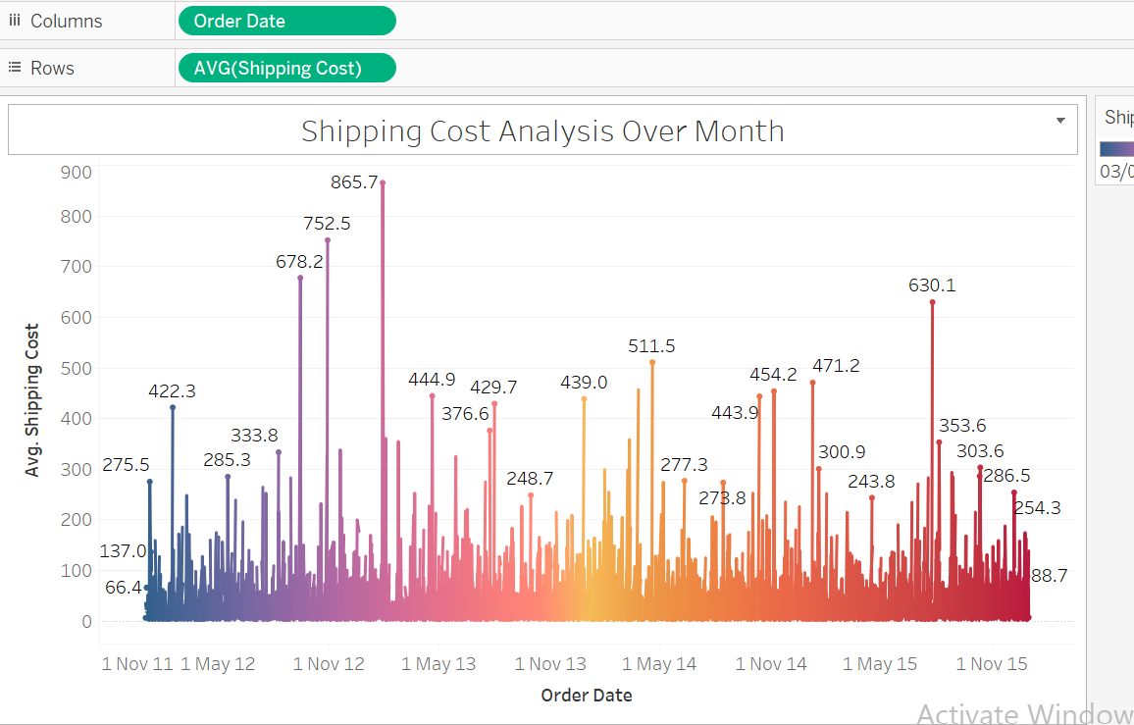

**Visual 4:** Order Priority Breakdown

* Create a pie chart showing the distribution of orders by order priority.
* Use table calculation percentage of total.
* Allow users to filter the data by segment and region.   
  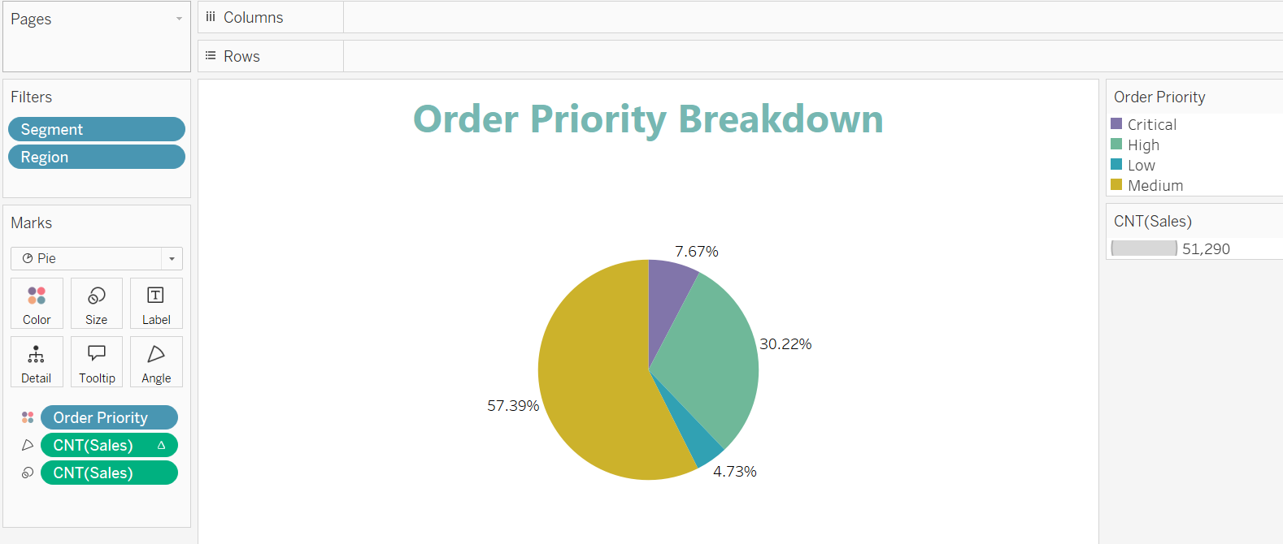

**Dashboard Creation:**

* Combine the four visuals into a single dashboard.
* Add interactivity by linking filters across the different visuals.
* Ensure the dashboard is user-friendly and visually appealing.

https://public.tableau.com/views/Superstoresalesoverview_17466269298260/SuperstoreSalesOverview?:language=en-GB&publish=yes&:sid=&:redirect=auth&:display_count=n&:origin=viz_share_link

